**SPRINT 3**

|  |  |
| --- | --- |
| Date | 03 November 2022 |
| Team ID | PNT2022TMID40580 |
| Project Name | DETECTING PARKINSON’S DISEASE USING  MACHINE LEARNING |
| Maximum Marks | 4 Marks |

5. Initialize a MinMaxScaler and scale the features to between -1 and 1 to normalize them. The MinMaxScaler transforms features by scaling them to a given range. The fit_transform() method fits to the data and then transforms it. We don’t need to scale the labels.

* 1. #DataFlair - Scale the features to between -1 and 1
  2. scaler=MinMaxScaler((-1,1))
  3. x=scaler.fit_transform(features)
  4. y=labels

**Screenshot:**

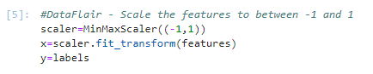

6. Now, split the dataset into training and testing sets keeping 20% of the data for testing.

* 1. #DataFlair - Split the dataset
  2. x_train,x_test,y_train,y_test=train_test_split(x, y, test_size=0.2, random_state=7)

**Screenshot:**

Top Python Project 